Experiment No – 3

Title / Aim :- Implement control structures and form validation; create a grading system based on user-entered marks.

Software/Tools Required :-
- Visual Studio Code (VS Code)
- Google Chrome / Any Web Browser
- HTML
- JavaScript

THEORY :-
The Student Grading System is developed using HTML and JavaScript to demonstrate the use of form validation and control structures. HTML is used to create a form for entering student marks, while JavaScript validates the input to ensure marks are within the valid range (0–100). The program uses if-else control statements to assign grades based on the marks entered. The entered data is then displayed as a grade card showing subject-wise marks, grades, percentage, and the overall grade.
OUTPUT:-
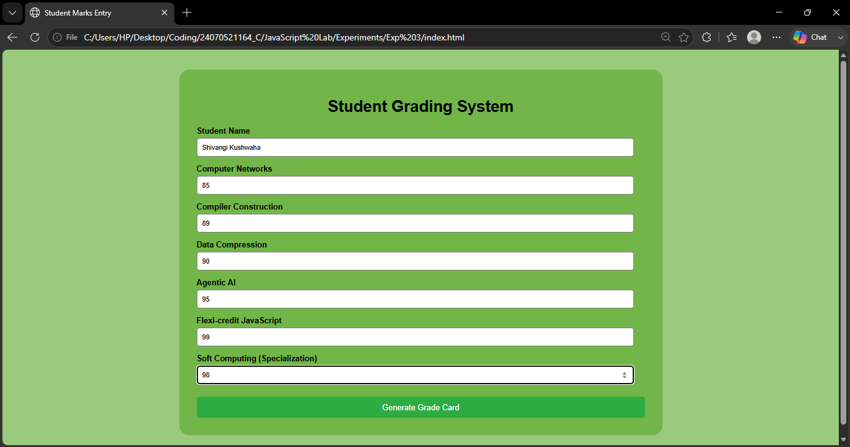

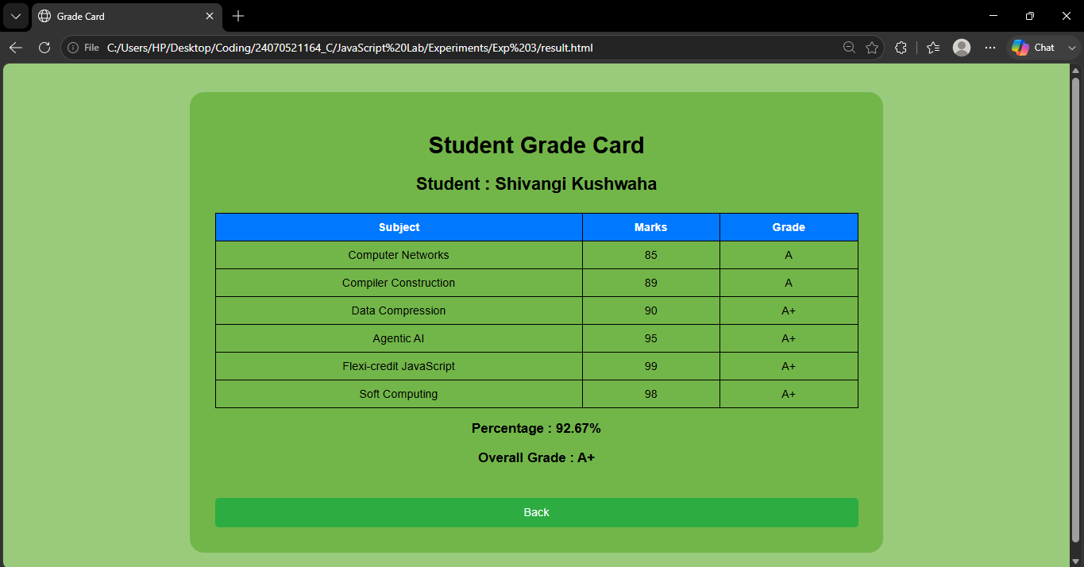

Result / Conclusion :-
The Student Grading System was successfully implemented using HTML and JavaScript. The system validated user input, calculated grades using control structures, and generated a clear grade card with subject-wise results, percentage, and overall grade. This project demonstrated the practical application of form validation, decision-making statements, and basic web development concepts.

